JChomp

$$\left[Rule\right]$$

 From up to down, the row and x-axis value are changed. When x-axis value increase 1 unit, the next row are increased by 1. From left to right, the col and y-axis value are changed. When y-axis value increase 1 unit, the next column are increased by 1. It is applied here and in my code.

More details on my note named JChomp intro.md which was published in GitHub.

$$\left[Coordinates\right]$$

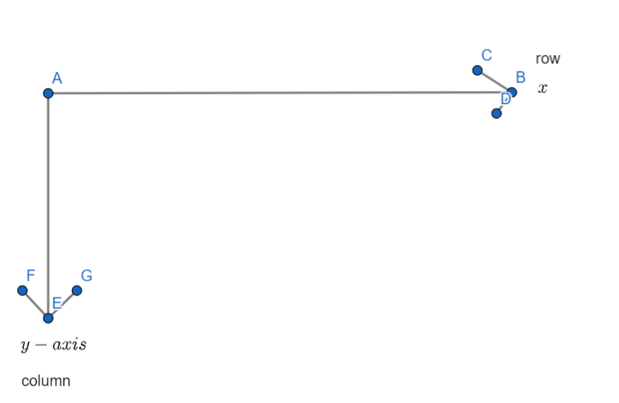

$$\left[NOTE\right]$$

$$NOTE that$$

$$1.We start at \left(0,0\right)$$

$$The top-left most block are at position \left(0,0\right).$$

$$2.\left(1\right)A block with a pair of numbers (n,r)$$

$$had already been eaten by the player n at the round r.$$

$$\left(2\right)A block without numbers or a pair of numbers refers$$

$$the block has NOT been eaten yet.$$

$$\left(3\right)A block with red text is poisoned.$$

$$\left[Example\right]$$

$$eg1:$$

$$Given a 7*4 board.$$

$$Assume one must eat 2 rows and 3 colums.$$

$$Assume there are two players.$$

$$Assume that blocks are at position$$

$$p=\left\{\left(0,3\right),\left(1,3\right)\right\}$$

$$are poisoned.$$

$$At start, the blocks are shown as follow.$$

|  |  |  |  |
| --- | --- | --- | --- |
|  |  |  | P |
|  |  |  | P |
|  |  |  |  |
|  |  |  |  |
|  |  |  |  |
|  |  |  |  |
|  |  |  |  |

|  |  |  |  |
| --- | --- | --- | --- |
| (1,1) | (1,1) | (1,1) | P |
| (1,1) | (1,1) | (1,1) | P |
|  |  |  |  |
|  |  |  |  |
|  |  |  |  |
|  |  |  |  |
|  |  |  |  |

|  |  |  |  |
| --- | --- | --- | --- |
| (1,1) | (1,1) | (1,1) | P |
| (1,1) | (1,1) | (1,1) | P |
|  |  |  |  |
|  | (2,1) | (2,1) | (2,1) |
|  | (2,1) | (2,1) | (2,1) |
|  |  |  |  |
|  |  |  |  |

|  |  |  |  |
| --- | --- | --- | --- |
| (1,1) | (1,1) | (1,1) | P |
| (1,1) | (1,1) | (1,1) | P |
|  |  |  |  |
|  | (2,1) | (2,1) | (2,1) |
|  | (2,1) | (2,1) | (2,1) |
|  |  |  |  |
|  |  |  |  |

|  |  |  |  |
| --- | --- | --- | --- |
| (1,1) | (1,1) | (1,1) | P |
| (1,1) | (1,1) | (1,1) | P |
|  |  |  |  |
|  | (2,1) | (2,1) | (2,1) |
|  | (2,1) | (2,1) | (2,1) |
|  |  |  |  |
|  |  |  |  |

|  |  |  |  |
| --- | --- | --- | --- |
| (1,1) | (1,1) | (1,1) | P |
| (1,1) | (1,1) | (1,1) | P |
|  |  |  |  |
|  | (2,1) | (2,1) | (2,1) |
|  | (2,1) | (2,1) | (2,1) |
| (1,2) | (1,2) | (1,2) |  |
| (1,2) | (1,2) | (1,2) |  |

|  |  |  |  |
| --- | --- | --- | --- |
|  |  |  |  |
|  |  |  |  |
|  |  |  |  |
|  |  |  |  |
|  |  |  |  |
|  |  | P |  |
|  |  | P |  |

|  |  |  |  |
| --- | --- | --- | --- |
| (1,1) | (1,1) | (1,1) |  |
| (1,1) | (1,1) | (1,1) |  |
|  |  |  |  |
|  |  |  |  |
|  |  |  |  |
|  |  | P |  |
|  |  | P |  |

|  |  |  |  |
| --- | --- | --- | --- |
| (1,1) | (1,1) | (1,1) |  |
| (1,1) | (1,1) | (1,1) |  |
|  |  |  |  |
|  | (2,1) | (2,1) | (2,1) |
|  | (2,1) | (2,1) | (2,1) |
|  |  | P |  |
|  |  | P |  |

|  |  |  |  |
| --- | --- | --- | --- |
| (1,1) | (1,1) | (1,1) |  |
| (1,1) | (1,1) | (1,1) |  |
|  |  |  |  |
|  | (2,1) | (2,1) | (2,1) |
|  | (2,1) | (2,1) | (2,1) |
|  |  | P |  |
|  |  | P |  |

$$The result is player 1 loses this game.$$

$$For more details, see my note JChomp intro.md$$

$$which is published in GitHub.$$